**SVKM’S NMIMS  
SCHOOL OF TECHNOLOGY MANAGEMENT& ENGINEERING  
NAVI MUMBAI**Academic Year: 2020-2021

Program: B. Tech Stream: CSBS

Year: II Semester: III

Subject: OOP Roll No: A016

Date: 30 / 10 / 2020 No. of Pages:6

Name: Varun Khadayate

**FINAL TERM PRACTICAL EXAM**

**Instructions:  
1) Code relevant to each question must start from a fresh page.   
2) Figures in brackets on the right-hand side indicate full marks.  
3) Assume Suitable data where necessary.  
4)** **Both the questions are compulsory.**

**5) You can ask for changing one of the questions but for each change there will be a deduction of -2 marks.**

|  |  |  |
| --- | --- | --- |
| **Q1** |  | **[05]** |
| **Q2** |  | **[05]** |

**FINAL TERM PRACTICAL EXAM ANSWER SHEET**

**Q1: **

**COMPILER USED:** Codeblocks

**CODE:**

#include<iostream>

using namespace std;

class Account

{

int bal,dep,wid_amt,acc_no;

char name[30];

public:

void Acc_Details();

void GetBalance();

void Deposit();

void Withdraw();

void Display();

};

inline void Account :: Acc_Details()

{

cout<<"Enter your Name :: ";

cin>>name;

cout<<"\nEnter your account number :: ";

cin>>acc_no;

}

inline void Account :: GetBalance()

{

cout<<"\nEnter the balance of your account :: ";

cin>>bal;

}

inline void Account :: Deposit()

{

cout<<"\nEnter the amount you want to deposit in your account :: ";

cin>>dep;

}

inline void Account :: Withdraw()

{

cout<<"\nEnter the amount you want to withdraw from your account :: ";

cin>>wid_amt;

}

inline void Account :: Display()

{

cout<<"\nName of the Account holder:: "<<name;

cout<<"\nAccount number:: "<<acc_no;

cout<<"\nBalance in the account:: "<<bal;

cout<<"\nAmount deposited in your account:: "<<dep;

cout<<"\nAmount withdrawn from your account:: "<<wid_amt;

}

int main()

{

Account acc;

acc.Acc_Details();

acc.GetBalance();

acc.Deposit();

acc.Withdraw();

acc.Display();

return 0;

}

**SCREEN SHOT OF THE OUTPUT:**

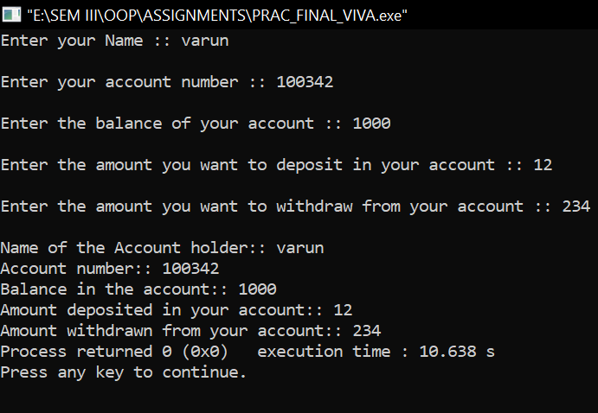

**Q2:**

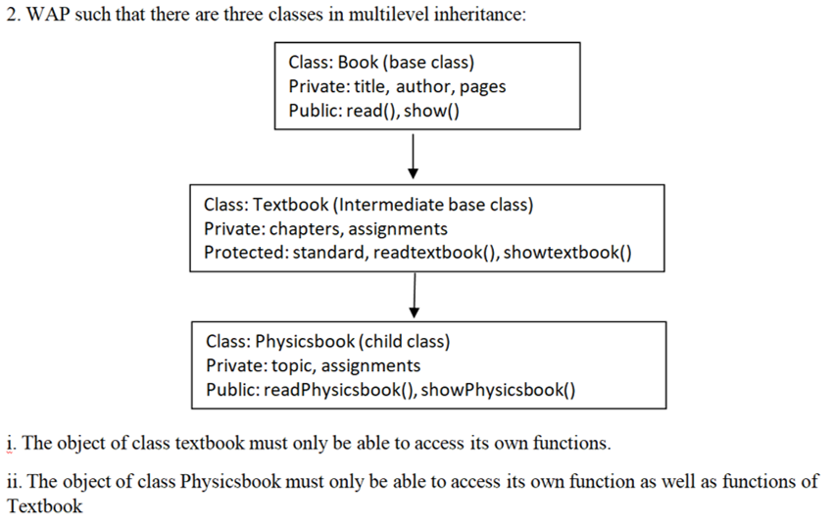

**COMPILER USED:** Codeblocks

**CODE:**

#include<iostream>

#include<conio.h>

#include<stdio.h>

using namespace std;

class Book

{

private:

int pages;

char title[30],author[30];

public:

void read()

{

cout<<"\nEnter Name of Book: ";

cin>>title;

cout<<"\nEnter Author of Book: ";

cin>>author;

cout<<"\nEnter Number if Pages of Book: ";

cin>>pages;

}

void display()

{

cout<<"\n\nName of Book: "<<title;

cout<<"\n\nAuthor of Book: "<<author;

cout<<"\n\nNumber of Pages of Book: "<<pages;

}

};

class TextBook : public Book

{

private:

int chapters,assignments;

protected:

int standard;

void readtextBook()

{

cout<<"\nEnter number of chapters of the book:";

cin>>chapters;

cout<<"\nEnter number of assignments of the book:";

cin>>assignments;

}

void showtextbook()

{

cout<<"\n\nNumber of chapters of the book:"<<chapters;

cout<<"\n\nNumber of assignments of the book:"<<assignments;

}

};

class PhysicsBook : public TextBook

{

private:

int topic,assignment;

public:

void readPhysicsbook()

{

readtextBook();

cout<<"\nEnter number of topics of the Physics book:";

cin>>topic;

cout<<"\nEnter number of assignments of the Physics book:";

cin>>assignment;

}

void display()

{

showtextbook();

cout<<"\n\nNumber of topics of the Physics book:"<<topic;

cout<<"\n\nNumber of assignments of the Physics book:"<<assignment;

}

};

int main()

{

TextBook b;

PhysicsBook p;

cout<<"\t Data Input";

b.Book::read();

p.readPhysicsbook();

cout<<"\n\n\t Data Output";

b.Book::display();

p.display();

return 0;

}

**SCREEN SHOT OF THE OUTPUT:**

